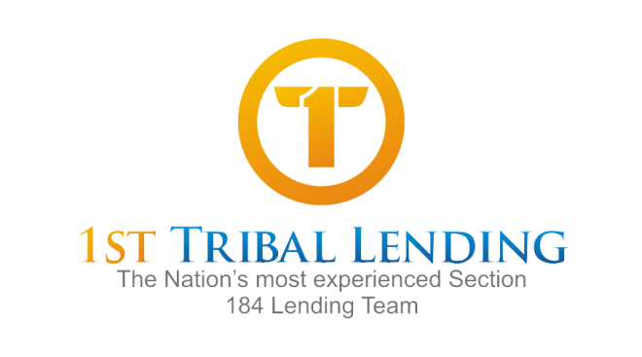
Dear 1st Tribal Lending Correspondent Lender:
We are pleased to be able to offer a comprehensive set of services to help facilitate your Section 184 business. Those services include underwriting, document preparation, and post-closing file insuring.
Because there have been some instances of miscommunication as to whether you or 1st Tribal was responsible for each function, we would like this opportunity to confirm your desired intentions.
The issue where we are both at greatest risk is the post-closing and insuring function. A paper file, including the credit package and closing docs must be sent to HUD Office of Native American Programs immediately after closing. Failure to send this package prior to the first payment date exposes the lender to being unable to obtain the Loan Guaranty Certificate if the borrower is late on a payment.
The lender then must wait for the borrower to make 6 consecutive payments on time before HUD will insure the loan. That exposes you to a buyback demand risk.
Please indicate below which services you are expecting 1st Tribal to provide. An officer or senior operations person should sign this request .

We would like 1st Tribal to underwrite our Section 184 Loans (Yes/No):______________________
Underwriting Fee: $380.00

We would like 1st Tribal to prepare our closing documents (Yes/No):________________________
Doc Prep Fee: $125.00

We would like 1st Tribal to send in our insuring packages to HUD (Yes/No):___________________
(If no, you must provide a tracking receipt proving that you have shipped the file to HUD)
Insuring Package Fee: $125.00

Thank you for responding to this request. If you have any questions, please contact your account representative or myself, Brett Robinson, Managing Director at 510-856-2186.

Acknowledged:__________________________________________________________________
Name Title Date

